**TASK 10: VALIDATION TASK**

**OSTWALD PROCESS**

Time allowed: 60 minutes **Total: 45 marks**

Name: _______________________________

Teacher: _______________________________

**Complete all questions in the space provided.**

**The following passage provides a brief summary of the reading that was provided on Connect.**

In 1914, a German chemist, Ostwald developed a process (now called Ostwald process) to manufacture nitric acid.

The Ostwald process consists of three main steps:

**Step 1: Catalytic oxidation of Ammonia**

A mixture of dry air and dry ammonia in the ratio of 10 : 1 by volume is compressed and then passed into a platinum gauze which acts as catalyst at about 800°C.

**4NH3(g) + 5O2(g)**⮀**4NO(g) + 6H2O(g) ΔH = -907 kJmol-1**

**Step 2: Oxidation of nitrogen monoxide (nitric oxide)**

Nitrogen monoxide combines with oxygen to form nitrogen dioxide at about 50°C.

**2NO(g) + O2(g)**⮀ **2NO2(g)**

**Step 3: Absorption of nitrogen dioxide in water**

The nitrogen dioxide and oxygen present in the air react with water to form nitric acid.

**4NO2(g) + 2H2O(l) + O2(g)** ⮀ **4HNO3(aq)**

Nitric acid obtained is concentrated above 50%. On further distillation, 68% nitric acid is produced.

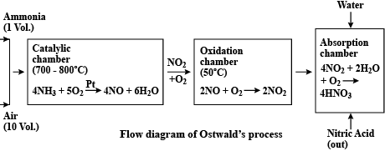

**Question 1 7 marks**

The Ostwald Process can be represented by the three equations below

4NH3(g) + 5O2(g) ⮀   4NO(g) + 6H2O(g)

2NO(g) + O2(g) ⮀ 2NO2(g)

4NO2(g) + 2H2O(l) + O2(g) ⮀ 4HNO3(aq)

With reference to knowledge of multi-steps processes,

(a) write an **overall** chemical equation for the Ostwald Process reactions above. (2 marks)

(b) calculate the mass of nitric acid that can be produced from 1.00 x 103 L of oxygen gas at S.T.P assuming the process is only 98.0% efficient. Express your final answer to the correct numberof **significant figures**. (5 marks)

**Questions 2 – 3 refer to the Catalytic oxidation of Ammonia in Step 1.**

4NH3(g) + 5O2(g) ⮀   4NO(g) + 6H2O(g) ΔH = - 907 kJmol-1

**Question 2 3 marks**

In the reaction above, the volume to volume ratio of ammonia to air in the reaction chamber must be carefully monitored and maintained at a numerical value of 1:10. If the volume to volume ratio of ammonia to air is higher than this ratio, the reaction mixture becomes explosive.

Literature research reveals that a **maximum** allowable (safe!)volume of ammonia of approximately 0.48L is needed per Litre of oxygen gas.

Show, by performing the necessary calculation, how the numerical answer of 0.48L was obtained. Assume air contains 20.98% oxygen **by volume**.

**Question 3 5 marks**

The typical operating conditions for the **Catalytic oxidation of Ammonia (see equation at the top of this page)** include:

1. Pressure of about 1,000 kPa and
2. Temperature between 820 – 930°C.

Using knowledge of reaction rates and Collision Theory, explain the effect of the **high pressure** stated above on the **rates** and **theoretical** **yield** of nitrogen monoxide (NO) gas.

_____________________________________________________________________________________

_____________________________________________________________________________________

_____________________________________________________________________________________

_____________________________________________________________________________________

_____________________________________________________________________________________

_____________________________________________________________________________________

_____________________________________________________________________________________

_____________________________________________________________________________________

_____________________________________________________________________________________

_____________________________________________________________________________________

_____________________________________________________________________________________

**Questions 4 4 marks**

The following question refers to **Step 2** of the Ostwald process where nitrogen monoxide combines with oxygen to form nitrogen dioxide at about 50°C. The chemical equation for this reaction is:

2NO(g) + O2(g)  ⮀ 2NO2(g) ΔH = -118.9 kJ/mol

State the effect of the following imposed changes on the equilibrium system above.

|  |  |  |  |
| --- | --- | --- | --- |
| **Imposed change** | **Effect on the rate of the forward reaction**  (write increase, decrease or no change) | **Effect on the yield of NO2**  (write increase, decrease or no change) | **Effect on the value of K**  (write increase, decrease or no change) |
| Temperature is increased to 80oC |  |  |  |
| The partial pressure of NO(g) is increased |  |  |  |
| Volume of reaction vessel is increased |  |  | **unchanged** |

**Question 5 2 marks**

Calculate the atom economy for the reaction: 2NO(g) + O2(g)  ⮀ 2NO2(g)

where the desired product is nitrogen dioxide. The relevant mathematical relationship is shown below.

**Atom economy = total molar mass of atoms in desired product x 100**

**total molar mass of atoms in all reactants**

**Question 6 8 marks**

A devout ‘Green’ chemist, after years of research, believed that he and his team of chemists had discovered a protein mixture to catalyse the reaction mentioned in Step 2. Apart from a faster rate of reaction, this biological catalyst would reduce heating needs and usage of non-renewable fossil fuels.

A chemical species, **X**, found in the protein mixture has the structure shown below.

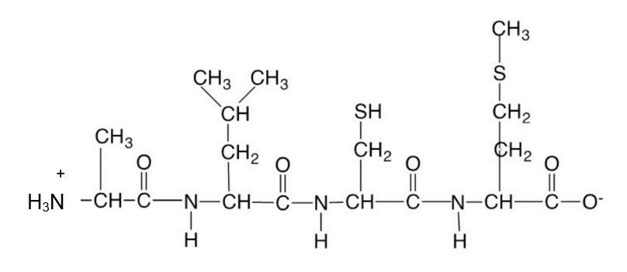

(a) Identify the amino acids in **X**. Use symbols to write the correct sequence of amino acids in **X** from left to right (e.g. Ala – Arg – Asn etc.) (2 marks)

**­**_______________________________________________________________________________

**For parts (b) and (c), choose one answer and write it in the box provided. Each question is worth 1 mark.**

(b) The aqueous solution containing **X** is most likely to have a pH of

(1 mark)

(i) 0

(ii) 2

(iii) 7

(iv) 12

|  |  |
| --- | --- |
| Answer |  |

(c) In an aqueous solution of **X**, what would be the **strongest** form of interaction between **X** and water molecules? (1 mark)

(i) Hydrogen bonds.

(ii) Dipole-dipole interaction.

(iii) Ion-dipole interaction.

(iv) Ionic attraction

|  |  |
| --- | --- |
| Answer |  |

(d) Another chemical species found in the catalyst mixture is the α-amino acid **valine**.Draw the structure of valine in a **solution** having a pH of 10. (1 mark)

|  |
| --- |
|  |

(e) Use the Chemistry Data Sheet provided to determine the **most dominant** interaction that may be formed between adjacent - R groups of the two polypeptides below. The interactions of interest are shown by the numbers **1, 2 and 3** in the diagram below.

(3 marks)

**Ser – Cys – Met – Thr**

**⏐ ⏐ ⏐**

**R R R**

**1 2 3**

**R R R**

**⏐ ⏐ ⏐**

**Gly – Cys - Val – Ser**

Name of dominant interaction shown by number 1: ___________________

Name of dominant interaction shown by number 2: ___________________

Name of dominant interaction shown by number 3: ___________________

**Question 7 9 marks**

After a series of repeated trials, a team member advised the ‘Green’ chemist that the biological catalyst may not be suitable. This advice was based on the photographs below showing the same protein structure at 35oC and at 42oC.

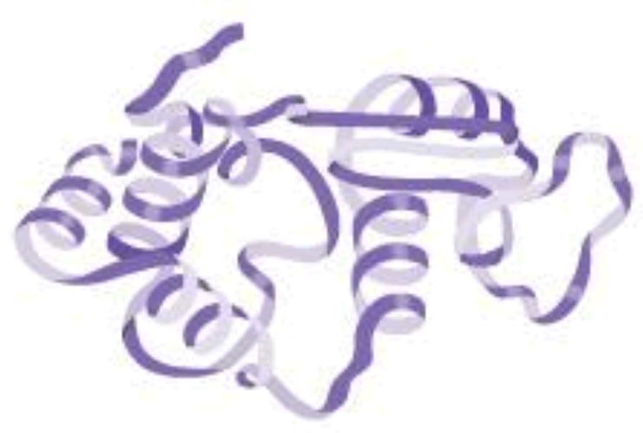 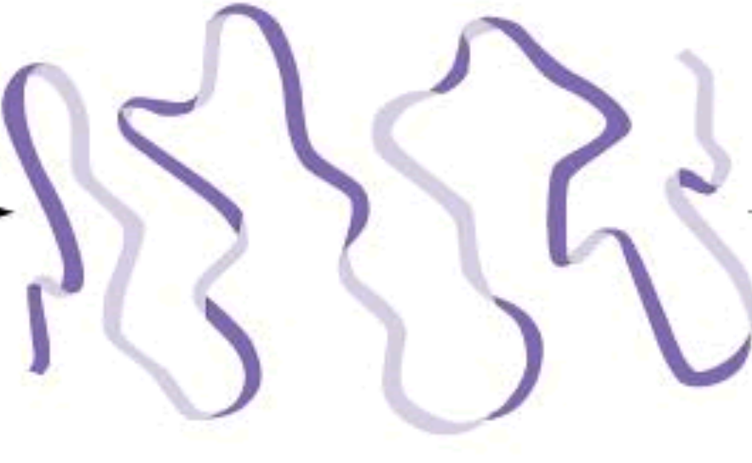

At 35oC At 42oC

(a) With reference to the knowledge of protein structures, provide a possible reason for the change observed in the photographs above. Explain your answer.

(3 marks)

_____________________________________________________________________________________

_____________________________________________________________________________________

_____________________________________________________________________________________

_____________________________________________________________________________________

_____________________________________________________________________________________

_____________________________________________________________________________________

_____________________________________________________________________________________

To confirm the team member’s finding, both the chemist and this team member carried out an investigation.

In one of the procedures, both chemists obtained 5.0mL samples of a similar biological catalyst solution from the spleen of mice and heated them. The heated samples were monitored and analysed by a Differential Scanning Colorimeter called the ‘M@gik’ meter.

The ‘M@gik’ meter provided a temperature reading upon detection of significant structural change to the proteins in the solution.

The results (in oC) obtained are shown in the table below:

|  |  |  |  |  |  |
| --- | --- | --- | --- | --- | --- |
|  | Temperature at which structural change is observed (oC) | | | | |
|  | Trial 1 | Trial 2 | Trial 3 | Trial 4 | Trial 5 |
| Green chemist | 40.0 | 40.0 | 42.0 | 42.0 | 42.0 |
| Team member | 40.5 | 40.0 | 40.0 | 39.8 | 40.0 |

(b) State the independent and dependent variables for this investigation. (2 marks)

|  |  |
| --- | --- |
| Independent variable |  |
| Dependent variable |  |

(c) State one variable that needs to be **controlled** for this investigation. (1 mark)

_______________________________________________________________________________

(d) What would the chemists need to do to ensure that the investigation was reliable? (1 mark)

_______________________________________________________________________________

(e) Identify one potential safety risk associated with this investigation and briefly describe how this risk could be minimised. (2 marks)

|  |  |
| --- | --- |
| Description of risk |  |
| How this risk may be minimised |  |

**The following questions refer to Steps 1 – 3 in the Ostwald Process.**

**Question 8 2 marks**

Use knowledge of the Ostwald process and principles of Green Chemistry, describe

(a) one (1) potential health issue that is known to be associated with escaping nitrogen monoxide and nitrogen dioxide gases. (1 mark)

_______________________________________________________________________________

_______________________________________________________________________________

(b) one (1) operating procedure that is used to minimise the leakage of nitrogen monoxide and nitrogen dioxide gases to the atmosphere. (1 mark)

_______________________________________________________________________________

_______________________________________________________________________________

_______________________________________________________________________________

**The following question refers to the Absorption of nitrogen dioxide in water in Step 3.**

**Question 9 5 marks**

**The chemical equation for the process is 4NO2(g) + 2H2O(l) + O2(g)** ⮀ **4HNO3(aq)**

In an efficiency trial, 0.40 g of nitrogen dioxide is allowed to react with 100.0 mL of oxygen gas at 200.0oC and 100.0 kPa. Determine

(a) the limiting reactant. (3 marks)

(c) In a separate trial, 3.00g of oxygen gas was reacted with excess steam and nitrogen dioxide. Given that the actual mass of 3.00g of nitric acid was produced, calculate the percentage yield of this trial.

(2 marks)

**END OF PAPER**